Test 1 - Dynamic Power Savings Mode

**Dynamic Power Savings Mode**—Automatically varies processor speed and power usage based on processor utilization. This option allows the reduction of overall power consumption with little or no impact to performance. It does not require OS support.

CPUZ Bench

|  |  |
| --- | --- |
| First execution | Second execution |

SQL Server test

Test 1 – Small table

USE tempdb

GO

IF OBJECT_ID('TabTest1') IS NOT NULL

DROP TABLE TabTest1;

CREATE TABLE TabTest1(Col1 CHAR(500));

INSERT INTO TabTest1

SELECT TOP 50000

CONVERT(CHAR(100), 'Test, fixed data to be used on test') AS Col1

FROM master.dbo.sysobjects A,

master.dbo.sysobjects B,

master.dbo.sysobjects C,

master.dbo.sysobjects D

OPTION (MAXDOP 1);

UPDATE STATISTICS TabTest1 WITH ROWCOUNT = 1000000, PAGECOUNT = 100000

GO

-- Quick scan to make sure all pages are in cache

SET STATISTICS IO ON

SELECT COUNT(*) FROM TabTest1

SET STATISTICS IO OFF

GO

SET STATISTICS IO, TIME ON

GO

DECLARE @Col1 CHAR(100)

SELECT TOP 100 @Col1 = Col1 FROM TabTest1

ORDER BY Col1

OPTION (MAXDOP 1)

SELECT TOP 100 @Col1 = Col1 FROM TabTest1

ORDER BY Col1

OPTION (MAXDOP 8)

SELECT TOP 100 @Col1 = Col1 FROM TabTest1

ORDER BY Col1

OPTION (MAXDOP 16)

GO

SET STATISTICS IO, TIME OFF

GO

/*

SQL Server parse and compile time:

CPU time = 0 ms, elapsed time = 0 ms.

Table 'TabTest1'. Scan count 1, logical reads 3334, physical reads 0, read-ahead reads 0, lob logical reads 0, lob physical reads 0, lob read-ahead reads 0.

(1 row affected)

SQL Server Execution Times:

CPU time = 984 ms, elapsed time = 991 ms.

Table 'TabTest1'. Scan count 9, logical reads 3334, physical reads 0, read-ahead reads 0, lob logical reads 0, lob physical reads 0, lob read-ahead reads 0.

(1 row affected)

SQL Server Execution Times:

CPU time = 1030 ms, elapsed time = 219 ms.

Table 'TabTest1'. Scan count 17, logical reads 3334, physical reads 0, read-ahead reads 0, lob logical reads 0, lob physical reads 0, lob read-ahead reads 0.

(1 row affected)

SQL Server Execution Times:

CPU time = 545 ms, elapsed time = 104 ms.

SQL Server parse and compile time:

CPU time = 0 ms, elapsed time = 0 ms.

Completion time: 2020-09-09T01:28:31.0113308-03:00

*/

SQL Query Stress tests:

|  |  |
| --- | --- |
|  |  |
|  |  |

Profiler:

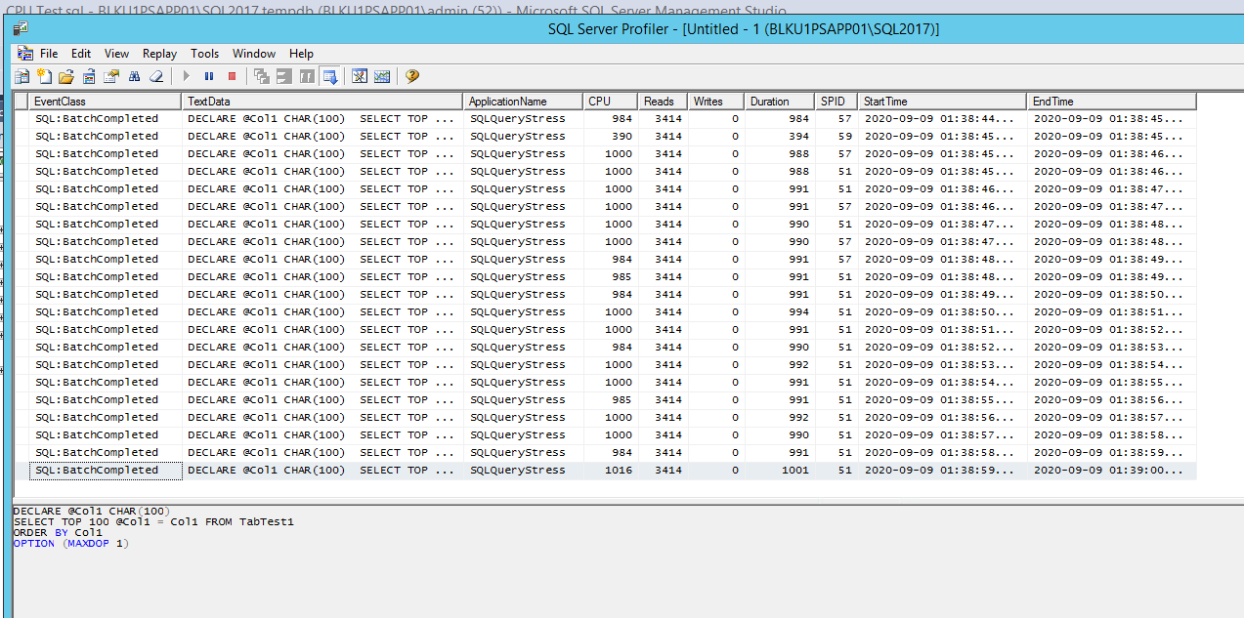

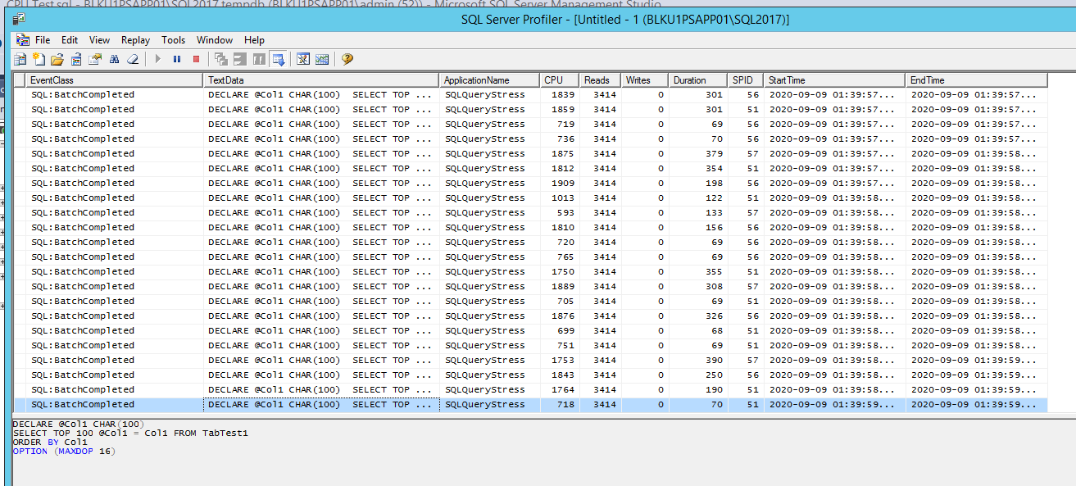

Perfmon counters

